TASK 1 – TABLE WITHOUT INDEX
For correct results we need to set no run parallel process (because every time can run multiple parallel process).
What I got with ‘explain’ is same result for checking plan twice. Result is same
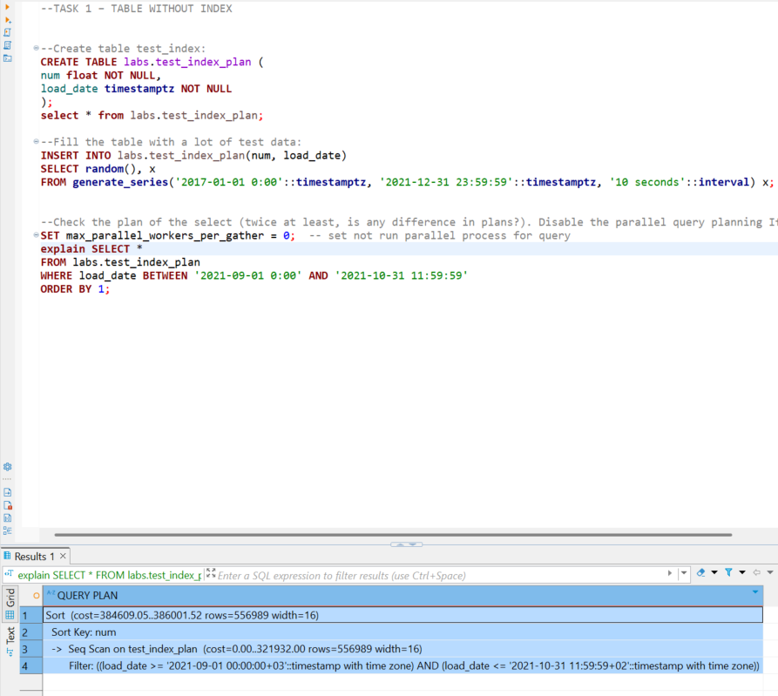

Without index using sequent scan.
Analyze add statistics in plan about running time. When I use explain analyze I get more Query plan rows like :
- planning time: 0.077 ms
- execution time: 1150.234 ms
when I use explain analyze second time execution time a little bit changing . This is normal. We use here random() function so time can be quicker and not. If we don’t have random function I think we have second result always quicker, because we have caching effect (first time it is read from disk and second time from RAM)
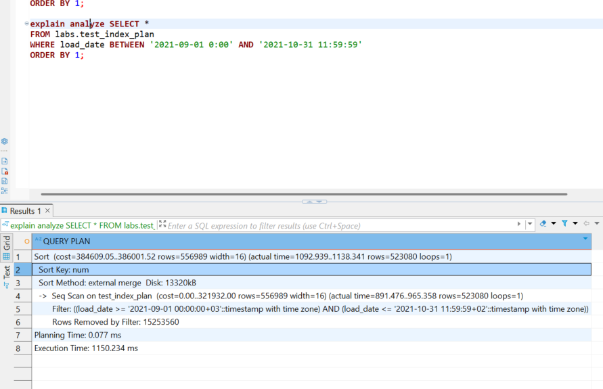
When we run explain (analyze, buffers) we get information about how many pages we from caching pages and how much from disk (some operation need to connect to disk always)
In results “ Buffers: shared hit=16211 read=69069 …” we see that 16211 buffer pages founded on RAM and 69069 from disk
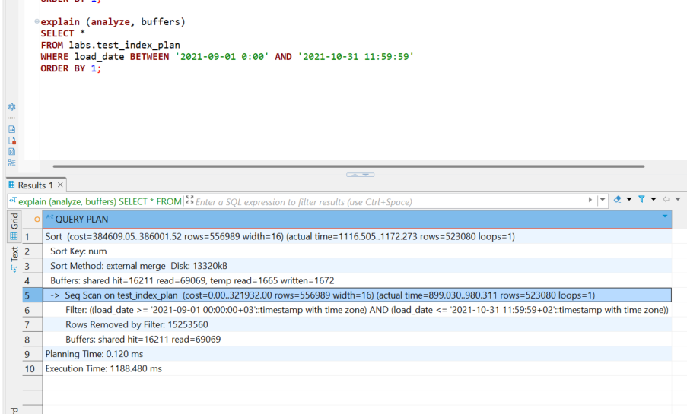
So we have always query changing time, others values are same. Time can change by many parametrs, especially from: caching, disk I/O and system resources. First run of a query may have higher execution time due to data not being cached, whereas the second run might be faster because the data is already in memory.
TASK 2 – ADDING INDEX
Here we use index scan. Using Explain … running with b-tree index cost is more than 4 time lower 384609/82942 ~ 4.6 x
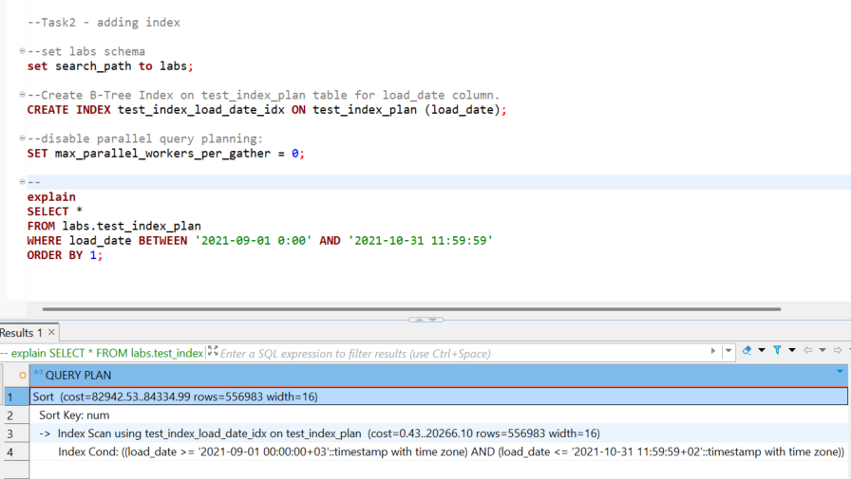

Using Explain analyze … with b-tree index execution time more than 4 times lower 😊
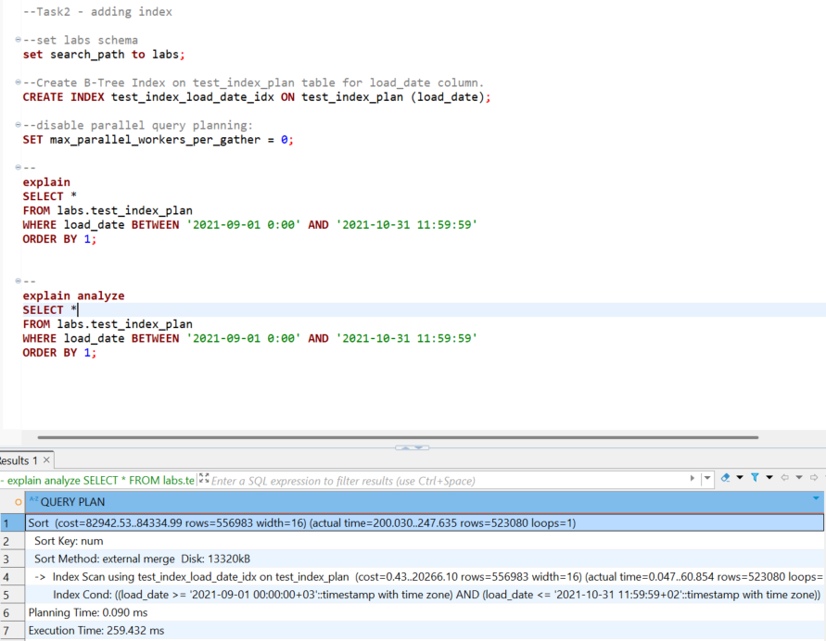

Using explain analyze, buffers . Shows additional how much values are readed from cash and disk … with b-tree index execution time more than 4 times lower 😊
Results without index : hit=16211, read=69069 .. so founded buffer pages on RAM 16211 , on disk 69069
Results with b-tree index : hit=2009 … so founded buffer pages on RAM 2009 , on disk 0

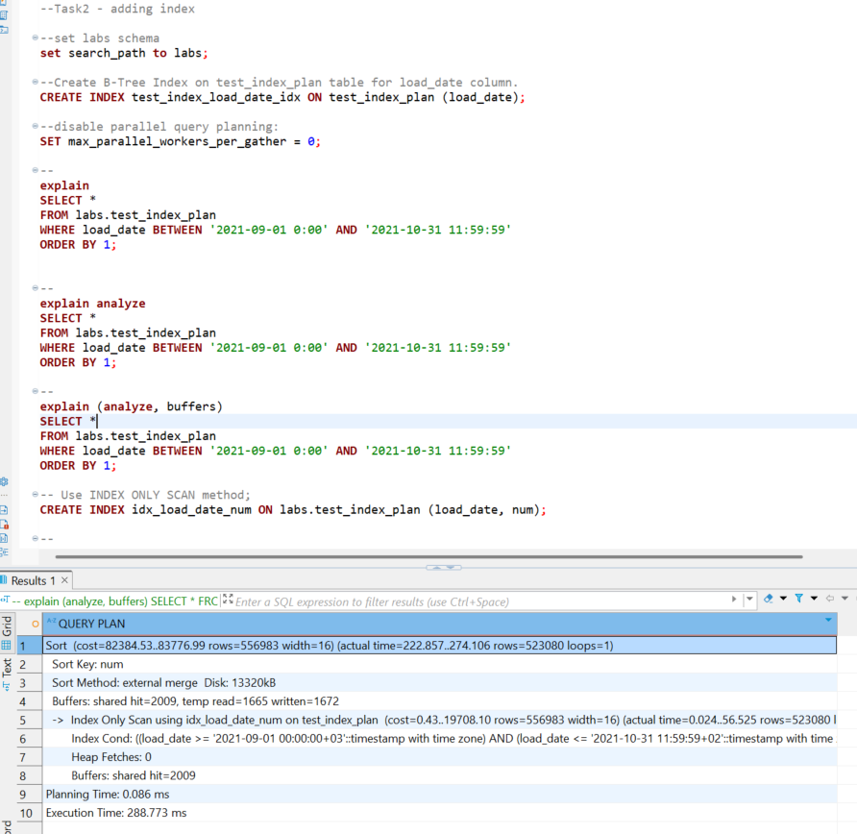
----------------------------
Ok when I create index only scan that mean Postgre don use table only index (I use index on all table colums)
-- Use INDEX ONLY SCAN method;
CREATE INDEX idx_load_date_num ON labs.test_index_plan (load_date, num);

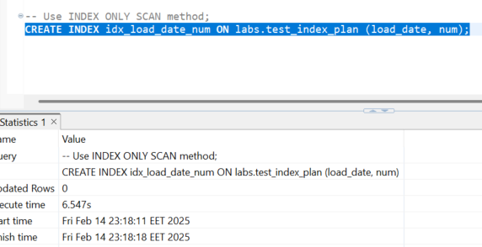

Using Index Only Scan a little bit cost is less 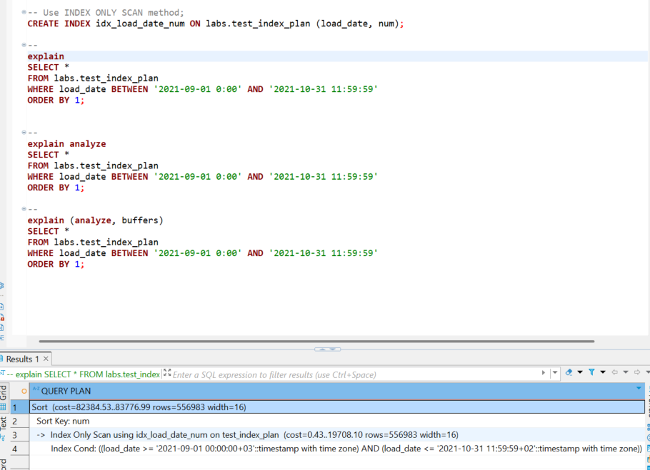

Same with time when using index only scan. But here we see that it is used only index tables on RAM and no tables on disk
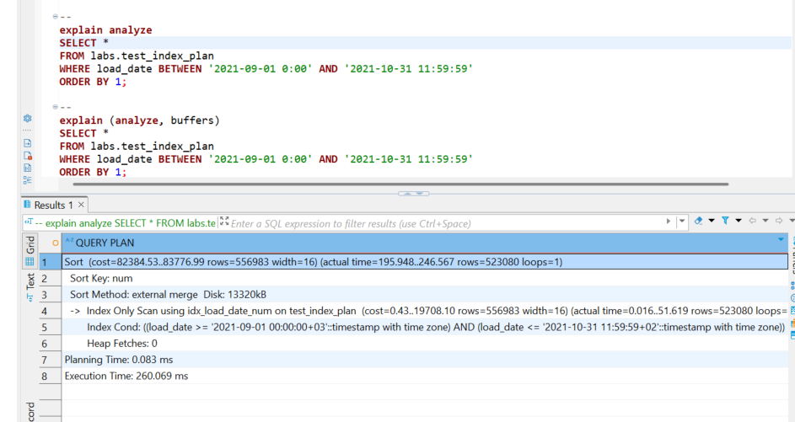

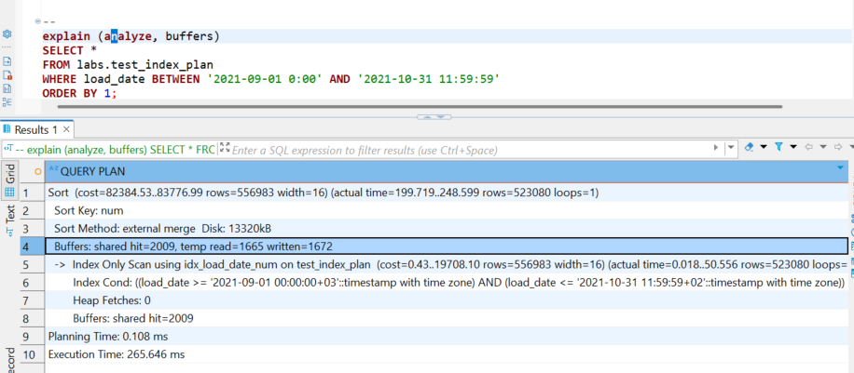
Result on select query no index VS B-tree:
Results without index : hit=16211, read=69069 (read from disk), execution time = 1188.480 ms . Executor used only tables from RAM = 16211, so we have so so much time used;
Results without b-tree index : hit=4260, heap fetches=0, execution time = 295.853 ms. Executor used: index tables from RAM + tables from RAM = 4260, so less time used;
Results with Index only scan : hit=2009, Heap Fetches: 0 (read from disk 0), execution time = 265.646 ms . Executor used only index tables from RAM = 2009 so best time used;
I think if here we don’t have sorting we have reduce procentaly best execution time … I hope You understand what I mean 😊 oh my English 😊
p.s. interesting moment that when I run query after I make index only scan method planner use this method on query, not b-tree, because it is best effective

Now we create BRIN index
CREATE INDEX idx_brin_load_date ON labs.test_index_plan using brin (load_date);

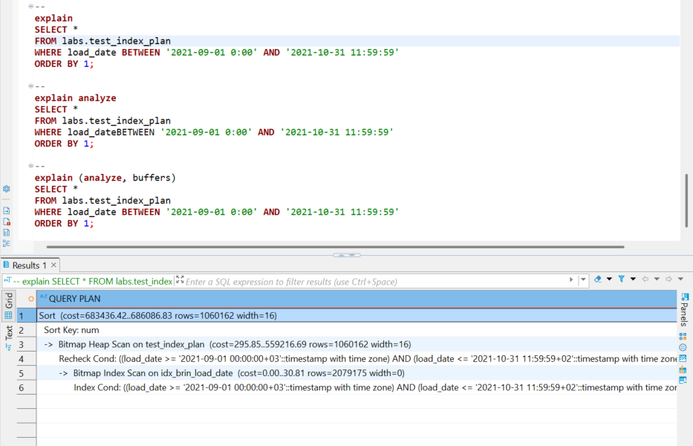
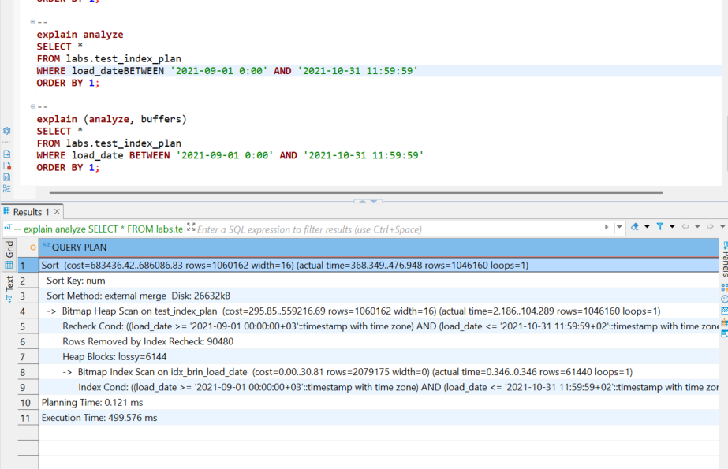
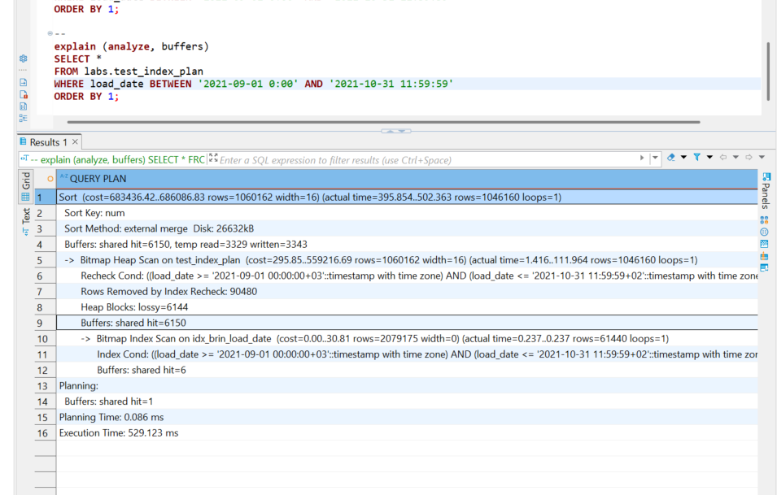

Result on select query B-tree VS BRIN:
Results without index : hit=16211, read=69069 (read from disk), execution time = 1188.480 ms . Executor used only tables from RAM = 16211, so we have so so much time used;
Results with b-tree index : hit=4260, heap fetches=0, execution time = 295.853 ms. Executor used: index tables from RAM + tables from RAM = 4260, so less time used;
Results with Index only scan : hit=2009, Heap Fetches: 0 (read from disk 0), execution time = 265.646 ms . Executor used only index tables from RAM = 2009 so best time used;
Results with BRIN index : hit=6150, Heap Fetches: 0 (read from disk 0), execution time = 558.442 ms . Executor used only index tables from RAM = 6150 .. here lot buffer pages so time is higher than with b-tree;

Here I try brin without order by and result is great only 140.286 ms
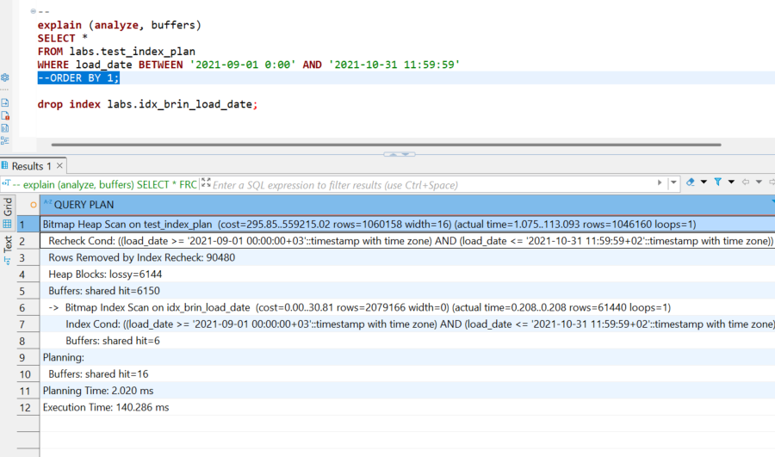
So Brin indexing data with diapason blocks and if we need sorting in our query it will be additional operation so need additional time for that. When we have query with sorting B-tree index is quicker than brin, because he have structured sorted index and don’t need additional to sorting data. Brin is quicker without sorting data (like You see on becture it is need only 140.286 ms). Oh yeeee I think I got it 😊 for that HW we have 2 hours for do it ha ha ha …. Move on

TASK 3 BULK INSERT
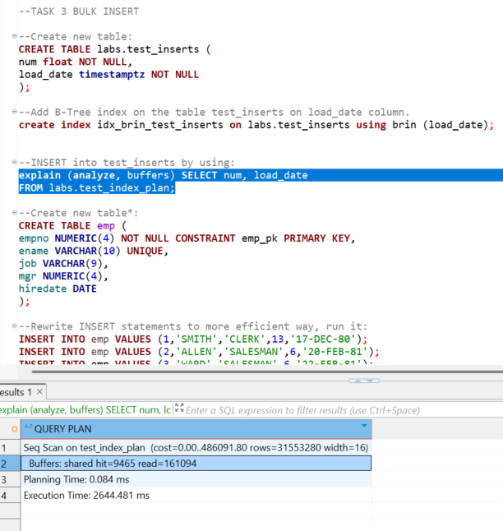
--We can rewrite query like that
insert into labs.emp (empno, ename, job,mgr, hiredate)
values
(1, 'SMITH', 'CLERK', 13, '17-DEC-80'),
(2, 'ALLEN', 'SALESMAN', 6, '20-FEB-81'),
(3, 'WARD', 'SALESMAN', 6, '22-FEB-81'),
(4, 'JONES', 'MANAGER', 9, '02-APR-81'),
(5, 'MARTIN', 'SALESMAN', 6, '28-SEP-81'),
(6, 'BLAKE', 'MANAGER', 9, '01-MAY-81'),
(7, 'CLARK', 'MANAGER', 9, '09-JUN-81'),
(8, 'SCOTT', 'ANALYST', 4, '19-APR-87'),
(9, 'KING', 'PRESIDENT', NULL, '17-NOV-81'),
(10, 'TURNER', 'SALESMAN', 6, '08-SEP-81'),
(11, 'ADAMS', 'CLERK', 8, '23-MAY-87'),
(12, 'JAMES', 'CLERK', 6, '03-DEC-81'),
(13, 'FORD', 'ANALYST', 4, '03-DEC-81'),
(14, 'MILLER', 'CLERK', 7, '23-JAN-82');

- or we can rewrite with with copy command
COPY labs.emp (empno, ename, job, mgr, hiredate)
FROM 'C:/Program Files/PostgreSQL/17/data/EPAM_study/emp_data.csv'
DELIMITER ','
CSV HEADER;

TASK 4 COPY COMMAND
--Use COPY Command to export your test_index_plan table into csv file:
COPY labs.test_index_plan TO
'C:\Program Files\PostgreSQL\17\data\EPAM_study\test_index_plan.csv' DELIMITER ',' CSV HEADER;

-- when want export load_date column with quotes
COPY (select num, '"' || load_date || '"' from labs.test_index_plan) TO
'C:\Program Files\PostgreSQL\17\data\EPAM_study\test_index_plan.csv' DELIMITER ',' CSV HEADER;

--Use COPY to export data from test_index_plan table into csv file ‘test_index_plan_short.csv’
--where load_date between '2021-09-01 0:00' AND '2021-09-01 11:59:59'

COPY (
select num, load_date
from labs.test_index_plan
where load_date between '2021-09-01 0:00' AND '2021-09-01 11:59:59') TO
'C:\Program Files\PostgreSQL\17\data\EPAM_study\test_index_plan_short.csv'
DELIMITER ',' CSV HEADER;

--Create new table:
CREATE TABLE labs.test_copy (
num float NOT NULL,
load_date timestamptz NOT NULL
);

--Add B-Tree index on the table test_inserts on load_date column.
create index idx_test_inserts on labs.test_inserts (load_date);

--COPY into test_copy by using test_index_plan.csv file.

copy labs.test_copy (num, load_date)
from 'C:\Program Files\PostgreSQL\17\data\EPAM_study\test_index_plan.csv'
DELIMITER ',' CSV HEADER;

What Happened and Why:
- Creating tables: The table test_inserts is created to hold two columns: num and load_date, and an index was added to optimize queries based on load_date.
- Exporting data: The COPY command is used to export data from the test_index_plan table to CSV files, both with and without filters on the load_date column.
- Efficient insertion: After exporting the data, the COPY command is used to insert data into the newly created test_copy table. The process is more efficient than using individual INSERT statements, as COPY is optimized for bulk data loading.
This workflow allows you to efficiently export and import large datasets in PostgreSQL, which is important for managing large amounts of data in an optimized way.

TASK 5 UPSERT
--Add into emp table following information in one UPSERT statement:
INSERT INTO labs.emp (empno, ename, job, mgr, hiredate)
values
(1, 'SMITH', 'MANAGER', 13, '01-DEC-21'),
(14, 'KELLY', 'CLERK', 1, '01-DEC-21'),
(15, 'HANNAH', 'CLERK', 1, '01-DEC-21'),
(11, 'ADAMS', 'SALESMAN', 8, '01-DEC-21'),
(4, 'JONES', 'ANALIST', 9, '01-DEC-21')
ON CONFLICT (empno)
DO UPDATE SET ename = EXCLUDED.ename, job = EXCLUDED.job, mgr = EXCLUDED.mgr, hiredate = EXCLUDED.hiredate;

What happens and why:
- The query attempts to insert the provided employee data into the emp table.
- If an empno already exists in the table (conflict), the query will update the existing record with the new values.
- If no conflict is found for an empno, the record will be inserted as usual.
This approach is useful for situations where you need to ensure that you don't end up with duplicate records for empno, and if the employee exists, their data will be updated.

